``


Student Name……………………………………

FURTHER MATHEMATICS

TRIAL EXAMINATION 2

2014

Reading Time: 15 minutes
Writing time: 1 hour 30 minutes

Instructions to students
This exam consists of a core and six modules.
The core contains a set of extended answer questions on Data Analysis.
These questions are compulsory and are worth 15 marks.
The six modules begin on page 7. You should choose 3 of these modules and answer every question in each of your chosen modules. Each of the modules is worth 15 marks.
The three modules are worth a total of 45 marks.
There is a total of 60 marks available for this exam.
The marks allocated to each of the questions are indicated throughout.
Students may bring one bound reference into the exam.
Students may bring into the exam one approved graphics calculator or approved CAS calculator or CAS software and, if desired, one scientific calculator. Calculator memory does not need to be cleared.
Formula sheets can be found on pages 36 and 37 of this exam.
Unless otherwise stated the diagrams in this exam are not drawn to scale.

This paper has been prepared independently of the Victorian Curriculum and Assessment Authority to provide additional exam preparation for students. Although references have been reproduced with permission of the Victorian Curriculum and Assessment Authority, the publication is in no way connected with or endorsed by the Victorian Curriculum and Assessment Authority.

© THE HEFFERNAN GROUP 2014
This Trial Exam is licensed on a non transferable basis to the purchasing school. It may be copied by the school which has purchased it. This license does not permit distribution or copying of this Trial Exam by any other party.

Core

Question 1 (2 marks)

This section is compulsory.

The number of times a member of a sports club attends a club game during a season is referred to as a “games attended total” (GAT). The bar chart below shows the GAT for 264 club members in five categories: never, sometimes, often, usually and always.

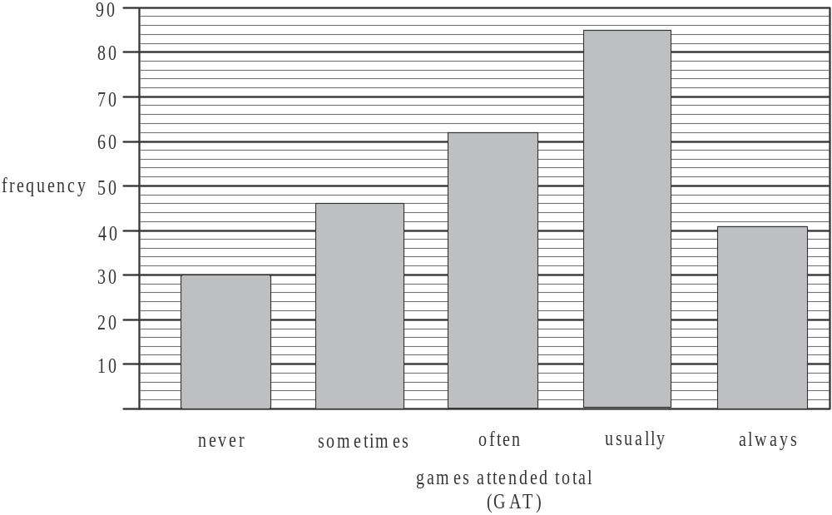

- In which category does the median games attended total (GAT) occur? 1 mark

________________________________________________________________

- What percentage of these 264 club members have a games attended total (GAT) in the “sometimes” or “often” categories. Express your answer to the nearest whole percentage. 1 mark

Question 2 (3 marks)

The GAT for a club member is a number from 0 to 25 (including both 0 and 25). The stem plot below shows the GAT for each of 21 junior club members who often or usually attend a club game.

GAT
1 | 0
1
1 | 5 | 5
1 | 7 | 7 | 7 | 7
1 | 8 | 8 | 8 | 9
2 | 0 | 0 | 1 | 1 | 1
2 | 2 | 3 | 3
2 | 4 | 4

- For this distribution find

- the mode. 1 mark

- the interquartile range. 1 mark

- Using an appropriate calculation, show that the junior member with a GAT of 10 is an outlier for this particular group of junior members. 1 mark

Question 3 (6 marks)

The GAT and the number of years of membership for 18 members are shown on the scatterplot below.
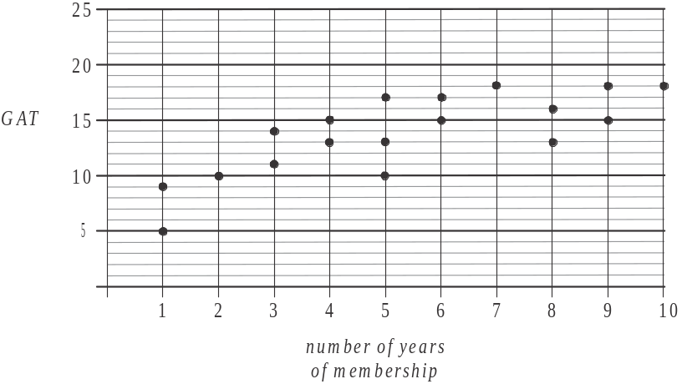

The equation of the least squares regression line for this data is

- Draw this least squares regression line on the scatterplot. 1 mark

- Use the least squares regression line to predict the GAT for someone who has been a member for 15 years.
Express your answer correct to the nearest whole number. 1 mark

- This set of data has a coefficient of determination of 0.5926.

  - Explain the coefficient of determination in terms of the variables GAT and number of years of membership. 1 mark

- Find the value of Pearson’s product - moment correlation coefficient. Express your answer correct to 3 decimal places. 1 mark

Using the data shown on the scatterplot together with the equation of the least squares regression line, a residual plot can be drawn. That residual plot is shown below.

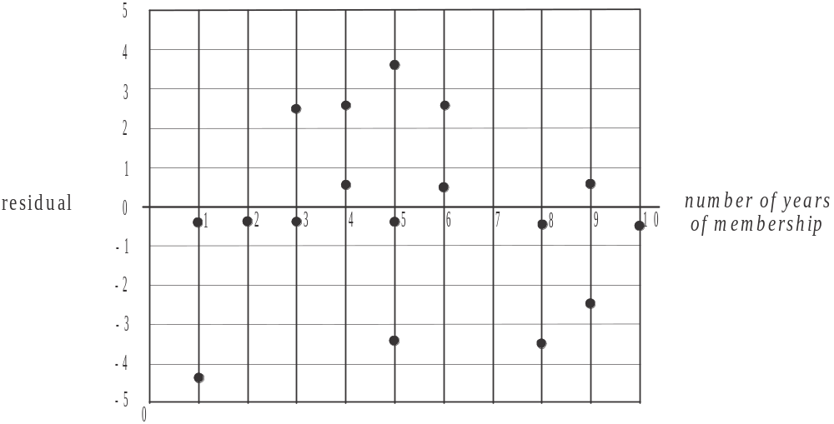

The residual for the piece of data representing the member with 7 years of membership has been omitted.

- i. On the residual plot above, draw the point that gives the residual for the piece of data representing the member with 7 years of membership. 1 mark

  - Explain why the residual plot supports the assumption that the relationship between the variables number of years of membership and GAT, is linear. 1 mark

Question 4 (4 marks)

The time series plot below shows the number of memberships sold by the sports club each year between 1996 and 2010.
A trend line has been fitted by eye to the data.

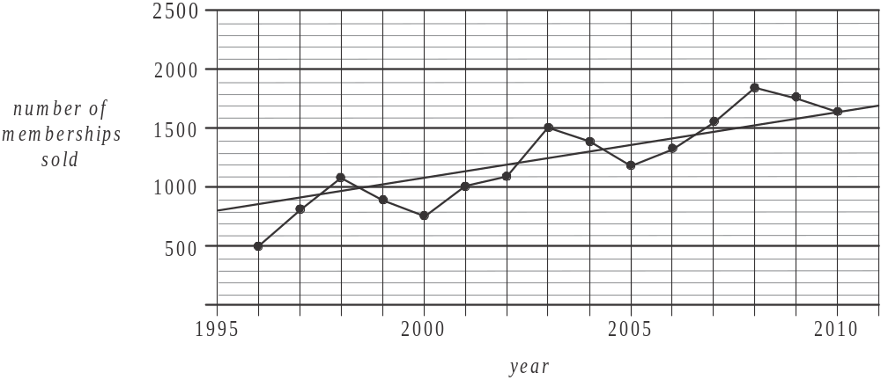

- Describe the features of the data shown in this time series plot. 1 mark

- i. According to the trend line that has been fitted, what is the annual increase in the number of memberships sold between 1996 and 2010? Express your answer to the nearest whole number. 1 mark

  - In how many of the years over the period 1996 – 2010, does the trend line overestimate the actual number of memberships sold? 1 mark

- The time series plot is to be smoothed using 5–moving median smoothing.
Find the smoothed value for 2003. 1 mark

Module 1: Number patterns

If you choose this module all questions must be answered.

Question 1 (3 marks)

An online business sells fruit and vegetables. In its first week of operation it had 1300 visits to its website.
In its second week it had 1750 visits and in its third week it had 2200 visits.
The number of visits to its website forms an arithmetic sequence.

- What is the common difference for this arithmetic sequence? 1 mark

- How many visits were made to the website in the eighth week of operation? 1 mark

- What was the total number of visits made to the website in the first twelve weeks of operation? 1 mark

Question 2 (4 marks)

In order to deliver the fruit and vegetables to online customers, the business model predicts that a certain number of new drivers will need to be added to the operation each week. In week four of the operation the model predicts that seventeen drivers in total will be working in the business. The number of drivers working in the business in the n^{th} week of operation is given by the difference equation

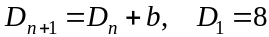
where b is a constant.

- i. Find the value of b. 1 mark

  - Write down the type of sequence generated by the difference equation given. 1 mark

The number of drivers who are expected to be working in the business in the n^{th} week of operation could alternatively be found using the equation.

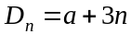
where a is constant.

- i. Find the value of a.
1 mark

  - Find the number of drivers who are expected to be working in the business in the fifteenth week of operation. 1 mark

Question 3 (2 marks)

The number of delivery vans predicted to be needed for the business forms a Fibonacci sequence with just one van required in the first and second weeks of operation.

- How many vans are predicted to be needed in the third week of operation? 1 mark

- In the week that the business is predicted to have twenty-six drivers working, there will be two drivers for each van.
In which week does this occur? 1 mark

Question 4 (3 marks)

The business purchases 2 600kg of produce at a wholesale market in its first week of operation.
In the second week it purchases 3 640kg and in the third week it purchases 5 096 kg.
The amount of produce purchased each week at the wholesale market forms a geometric sequence.

- Show that the common ratio for this sequence is 1.4. 1 mark

- During which week will the amount of produce purchased at the wholesale market first exceed 10 000kg. 1 mark

- During the first ten weeks of operation, what is the total amount of produce purchased at the wholesale market by the business. Express your answer to the nearest kilogram. 1 mark

Question 5 (3 marks)

The weekly number of deliveries made by the business to its online customers is expected to increase according to an arithmetic sequence.
Let 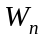 be the number of deliveries made in the n^{th} week of operation of the business where .

- Using the terms 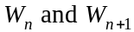, write down a difference equation that gives the number of deliveries expected to be made in successive weeks of operation. 1 mark

The average profit made by the business per delivery, is expected to increase by 5% each week as customers become familiar with the produce available.
The average profit made per delivery in week 1 was $20.

After the total profit made in a week first exceeds $30 000 the business will move to the next stage of its expansion.

- After which week of operation is the business expected to move to the next stage of its expansion? 2 marks

Module 2: Geometry and trigonometry

If you choose this module all questions must be answered.

Question 1 (4 marks)

A 70 metre long footpath runs between a milk bar at point M and an entry to the beach at point B. A water tank is located at point W, 20 metres due south of the milk bar.
The bearing of point M from point B is 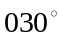
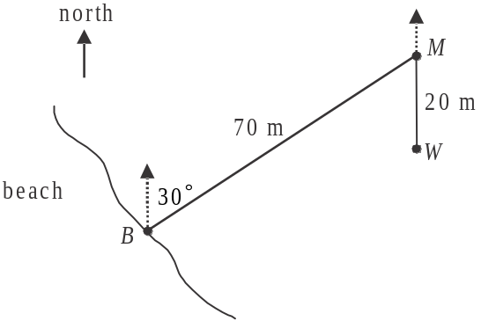

- Write down the size of the acute angle BMW. 1 mark

- How far west, in metres, is point B from the milk bar? 1 mark

- What is the bearing of point B from the milk bar? 1 mark

The distance from the water tank to point B is 53.62metres (correct to 2 decimal places).

- Find the bearing of the water tank from point B. Express your answer to the nearest whole degree. 1 mark

Question 2 (2 marks)

A semi-circular walking track of length 1250 metres starts at the milk bar and finishes at a lookout located at point L. A straight road runs between the milk bar and the lookout.

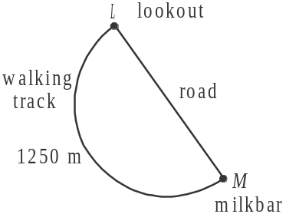

- Show that the length of the road is 795.77 metres, correct to 2 decimal places. 1 mark

- What is the area of the land enclosed by the walking track and the road? Express your answer in square metres correct to the nearest whole number. 1 mark

Question 3 (3 marks)

A contour map for the area surrounding the lookout is shown below. This area includes an entry to the beach at point B and a farmhouse at point F.

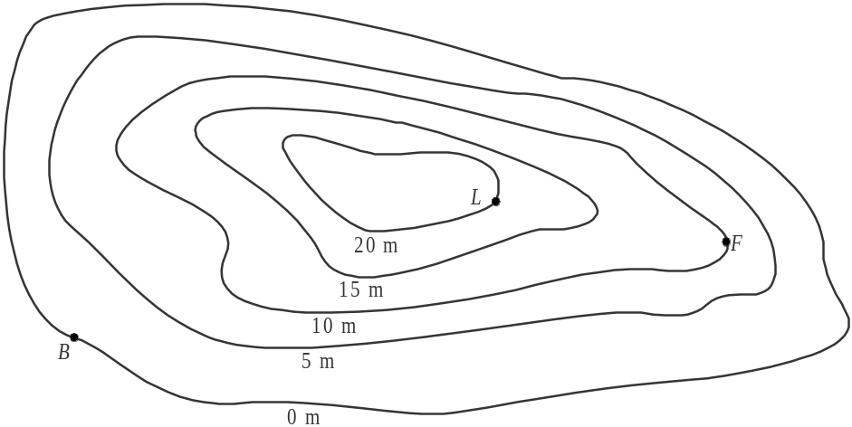

The contour interval on the map is 5m. On the contour map, 1 centimetre represents 200 metres on the horizontal level.
The length of the line BL on the contour map is 6.5cm.

- Find the horizontal distance from point B to the lookout. 1 mark

The horizontal distance from point F to the lookout is 700 metres.

- i. What is the angle of elevation of the lookout from point F? Express your answer to the nearest whole degree. 1 mark

  - What is the average slope between the lookout and point F? 1 mark

Question 4 (6 marks)

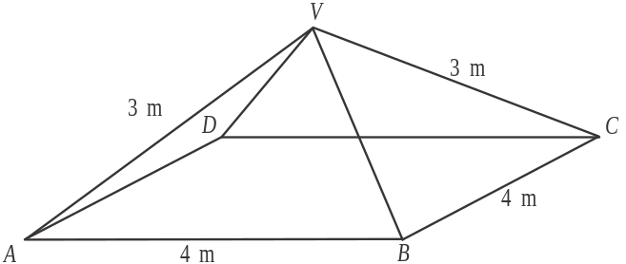

An historic stone monument in the shape of a square pyramid is located near the lookout.
The base, ABCD, of the pyramid has sidelengths of 4 metres and the slant edges are of length 3 metres.

- Find angle AVB. Express your answer in degrees correct to 2 decimal places. 1 mark

- Find the surface area (including the base) of the stone monument. Express your answer in square metres correct to 1 decimal place. 2 marks

- Find the height, in metres, of the monument. 2 marks

- A replica of the monument is made in concrete and is located near the milk bar.
The side length of the square base of the replica is 1 metre.

Given that the volume of the actual monument is 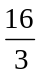 cubic metres, find the volume, in cubic metres, of the replica. 1 mark

Module 3: Graphs and relations

If you choose this module all questions must be answered.

Question 1 (5 marks)

Clem runs a dry cleaning business. Rachel is one of his employees who works for 3 ½ hours each day. She takes a half hour break during that time for which she is not paid. Rachel’s hourly pay rate depends on the task she is doing.
The pay versus time worked graph for Rachel is shown for a particular day when she started work at 10am.
The graph is incomplete.
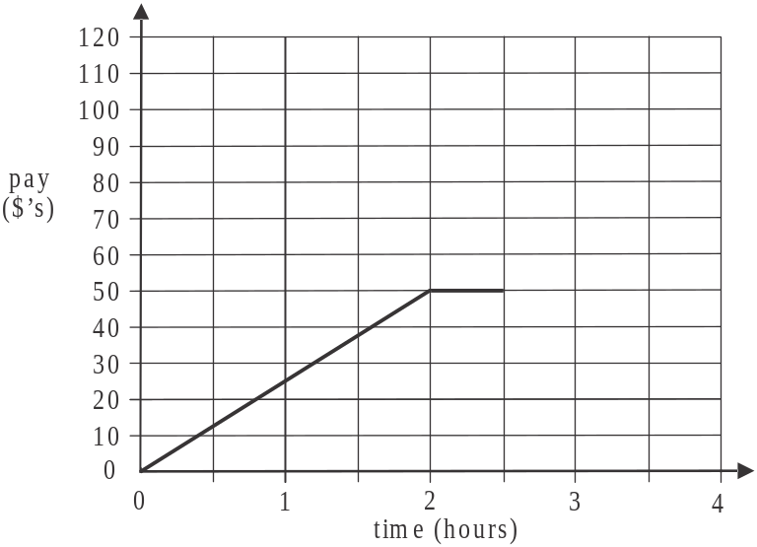

- Between what times did Rachel take her break on this day? 1 mark

- What was Rachel’s hourly pay before 12 noon? 1 mark

After Rachel’s break she changes tasks and is paid $30 per hour until she finishes for the day.

- Draw a line segment on the graph above that shows Rachel’s pay after the break. 1 mark

Rachel’s pay P, in dollars, for this day, t hours after she starts work is given by

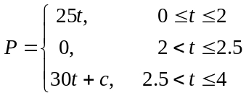

- Find the value of c. 1 mark

- What is the average rate per hour that Rachel is paid over the four hours? 1 mark

Question 2 (2 marks)

Clem offers a fast turn around dry cleaning service. For this service, the cost of having an item of clothing cleaned is determined by the period of time before the customer wants to collect the cleaned item.

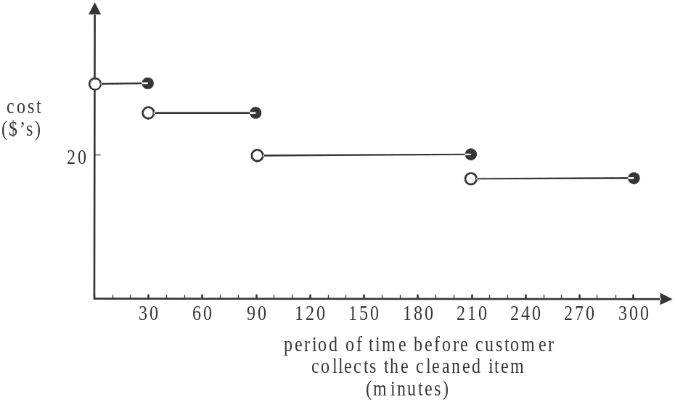

Jane has two items of clothing to be cleaned. She needs to collect them both in 2 hours.

- How much will this cost Jane? 1 mark

On Thursday Clem had a customer who needed 1 item cleaned in 45 minutes and another item cleaned in 4 hours. Clem charged this customer $43 in total. He had a second customer who needed 1 item cleaned in 3 hours and a second item cleaned in 5 hours.
Clem charged this customer $37 in total.

- What does it cost to have an item cleaned in 1 hour? 1 mark

Question 3 (2 marks)

Clem offers an ironing service whereby customers pay $3 per item to be ironed.
He employs someone to do the ironing and pays them $50 per day plus $1 per item ironed.

- Find an expression for the profit that Clem makes on this service in terms of the number, of items n, that are ironed in a day. Consider just the labour costs; that is,
ignore Clem’s other costs such as power and rent. 1 mark

- On a day when this service just breaks even for Clem, how much does the person doing the ironing earn? 1 mark

Question 4 (6 marks)

Because of the time taken in cleaning doonas and rugs, Clem limits the number of these items his business cleans in a day.

Let x be the number of doonas cleaned in a day.
Let y be the number of rugs cleaned in a day.

The limits imposed are given by the inequalities below.

Inequality 1:
Inequality 2: 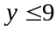
Inequality 3: 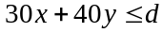

Inequality 3 relates to the staff time available to clean these two types of items.
There is a total of 8 hours of staff time available for the cleaning of doonas and rugs. It takes 30 minutes of staff time to clean a doona and 40 minutes of staff time to clean a rug.

- Find the value of d. 1 mark

Clem has an arrangement with a local hotel whereby they have at least 4 doonas cleaned every day.

- Express this as inequality 4 using the appropriate variable(s). 1 mark

Three of the four inequalities have their boundaries indicated by the straight lines shown on the graph below.

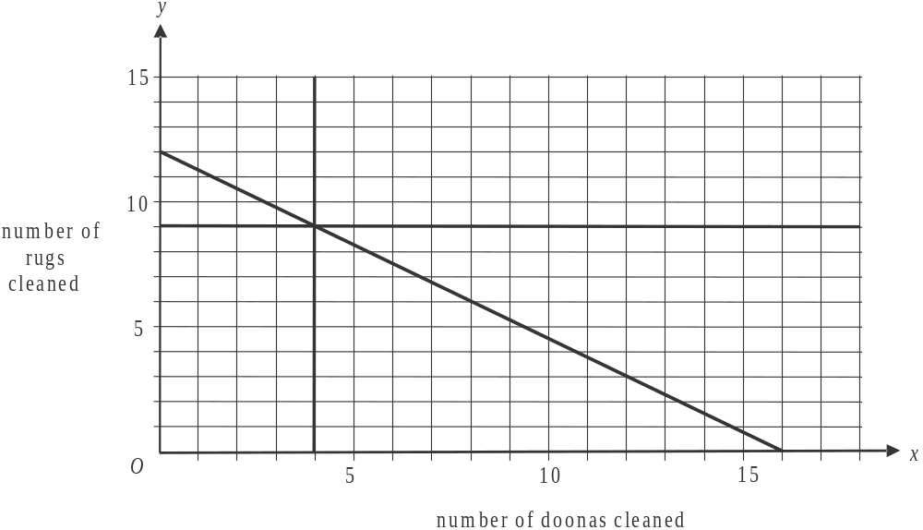

- Indicate on this graph the region that satisfies inequalities 1–4. 1 mark

Let T represent the total number of doonas and rugs cleaned in a day at Clem’s business.

- If T is to be a maximum, what is the largest number of doonas that can be cleaned in a
day? 1 mark

Clem makes $18 profit for every doona cleaned and $23 for every rug cleaned.

- What is the maximum profit Clem can make in a day from cleaning doonas and rugs? 1 mark

- If the number of rugs cleaned in a day is 3 more than the number of doonas cleaned on the same day, what is the maximum profit that Clem can make? 1 mark

Module 4: Business-related mathematics

If you choose this module all questions must be answered.

Question 1 (4 marks)

The selling price of a washing machine is $1600.

- Customers paying cash receive a 20% discount on this price.
What would a customer pay in cash for this washing machine? 1 mark

- Ken entered a hire-purchase agreement in order to buy the washing machine. He paid a deposit of $300.

i. What percentage of the selling price does this deposit represent? 1 mark

- The remaining amount was paid by Ken in 24 monthly instalments of $60.
How much interest did he pay in total? 1 mark

- What is the annual flat interest rate that applies in this hire-purchase arrangement?
Express your answer to the nearest whole percent. 1 mark

Question 2 (4 marks)

Phil inherits a sum of $35 000.

- He invests $20 000 in a perpetuity and receives $210 from it each quarter.
What is the annual interest rate for this perpetuity? 1 mark

- Phil invests the remaining $15 000 and obtains interest at the rate of 5.4% compounding quarterly.
What is this investment worth after 2 years? 1 mark

- i. Phil had the opportunity at the end of each quarter to add his perpetuity payment of $210 to his investment of $15 000 outlined in part b.
If Phil had elected to do this, what would his investment have been worth after 2 years? 1 mark

- How much more interest would Phil earn on his investment over the 2 years if he had elected to add, each quarter, the $210 to his initial investment of $15000? 1 mark

Question 3 (4 marks)

Phil purchases a dryer for $2800 which is to be used at his commercial laundry.

- The dryer is to be depreciated using the reducing balance method at the rate of 15% per year.

i. What is the depreciated value of Phil’s dryer after 3 years? 1 mark

- How long does it take for the initial value of the dryer to halve? Express your answer in years correct to 3 decimal places. 1 mark

- Suppose Phil has two other options to depreciate the dryer.

Option 1: using the flat rate method at the rate of 12% per annum.
Option 2: using the unit cost method at the rate of 2.5 cents per load, where the average number of loads per year is 12 000.

How long will it take in years, correct to 1 decimal place, for the book value of the dryer to reach $0 if it is depreciated using

- Option 1 1 mark

- Option 2 1 mark

Question 4 (3 marks)

In order to upgrade more equipment at his commercial laundry, Phil takes out a reducing balance business loan of $85 000 at 6.6% per annum interest.
He makes monthly payments of $2019.69.

- How long will it take Phil to fully repay this loan? 1 mark

- Two years into the loan agreement, Phil renegotiates the loan so that he will have it fully repaid one year later. The interest rate would remain at 6.6% per annum.
What will Phil’s monthly payments be now? 2 marks

Module 5: Networks and decision mathematics

If you choose this module all questions must be answered.

Question 1 (5 marks)

On a tropical island, the western section of a resort is comprised of eight villas. The villas, V1–V8, as well as the resort office, are shown as vertices on the network below. The distances, in metres, along the paths that exist between them are indicated on the edges of the network.
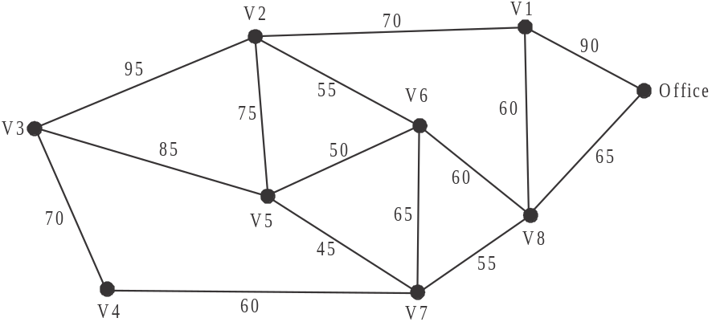

- How many vertices on the network shown above have an even degree? 1 mark

- What is the shortest distance between the office and 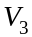? 1 mark

- A gardener starts at one of the villas and walks along every path, just once, finishing
at a different villa.
Which two villas could the gardener have started at or finished at? 1 mark

- The resort manager follows the route: .
Write down two words which give the mathematical term for the route followed by the resort manager. 1 mark

To save on maintenance, some of the paths shown on the network are to be closed. Despite these closures, each villa and the office must be able to be reached from every other villa (or the office).

- On the diagram below indicate clearly which paths should be left open so that the total distance along the remaining paths is a minimum. 1 mark
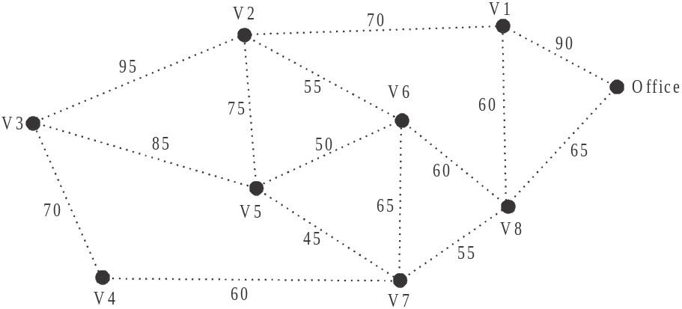

Question 2 (6 marks)

The tropical island sometimes faces the threat of a cyclone.
The resort manager has a list of tasks that must be undertaken around the resort when there is a cyclone alert.
These tasks, A – M, together with their duration in hours and the predecessor(s) for each task, are shown below.
Task | Duration  (hours) | Predecessor(s)
A | 4 | -
B | 6 | -
C | 7 | -
D | 5 | -
E | 4 | A
F | 3 | A
G | 4 | B, F
H | 5 | D
I | 6 | D
J | 5 | E
K | 7 | B, F
L | 5 | C, G, H
M | 4 | I

The network diagram below shows the information in the table. Task K has been left off the diagram.
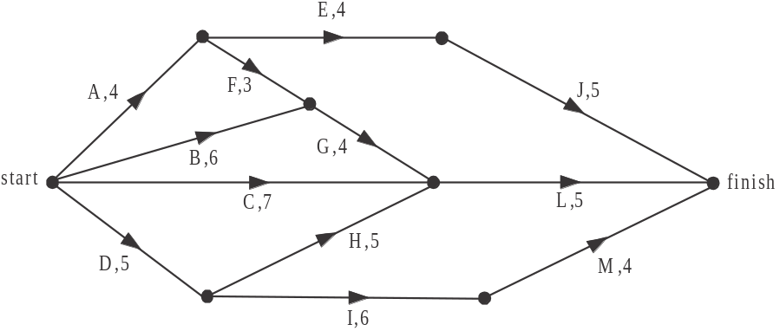

- By inserting task K, complete the network diagram above. 1 mark

- Find the earliest start time for task L. 1 mark

- What is the minimum time required to complete all the tasks? 1 mark

- Which task has the greatest slack (or float) time? 1 mark

On one occasion, after a cyclone warning has been given, the resort manager gains access to extra resources and is able to crash task G by 1 hour.

- Write down the tasks that are now critical to all the preparations being completed in the minimum possible time. 2 marks

Question 3 (4 marks)

Tourists who stay on the island where the resort is located, island A, can elect to travel back to the mainland at M by taking small boats which move between various other islands B, C, D, E and F and the mainland.
The total number of tourists the boats can carry in a day and the routes and direction they travel is shown on the directed network below.

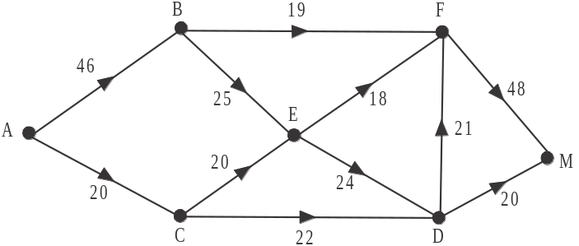

- What is the maximum number of tourists that can be carried in a day by the boats from island A to the mainland? 1 mark

On a particular day, an American tour group of 21 tourists are booked to travel from island A to the mainland. All 21 of these tourists must travel the same route.

- Write down the path that this American tour group must take. 1 mark

On the same day, three other tour groups, from Germany, UK and Japan, are also booked to travel from island A to the mainland using the boats. The German group is the largest and the Japanese group is the smallest. This means that on this day there is no available space for the general public to travel this route.
All members of a particular tour group follow the same route from island A to the mainland but different tour groups will take different routes.

- Complete the table below by writing down the maximum size of the German, UK and Japanese tour groups together with the possible routes they could take from island A
to the mainland. 2 marks

 | Tour group nationality
 | American | German | UK | Japanese
maximum size | 21
route taken | (part b. answer)
Module 6: Matrices

If you choose this module all questions must be answered.

Question 1 (3 marks)

At a fast food outlet, underground cabling runs between five areas. They are the

- kitchen (K)
- inside counter (I)
- drive-through order point (O)
- drive-through pay point (P)
- drive-through collection point (C)

The matrix A, below, shows the areas that are directly linked by underground cabling. A zero indicates no direct link between two areas and a one indicates a direct link between two areas, for example between K and I.
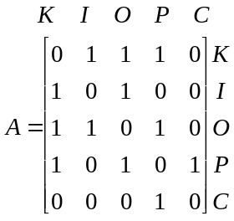

- Write down the order of matrix A. 1 mark

- Explain what the sum of the elements in column 2 of matrix A represent in terms of the areas and their direct link to one another. 1 mark

The diagram below that represents the information in matrix A is incomplete.

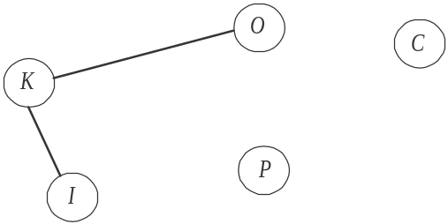

- Compete the diagram by inserting the missing edges. 1 mark

Question 2 (9 marks)

Staff at the fast food outlet start out as trainees 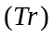.
Trainees either go on to become probationary staff members (Pr) or they leave (L).
Probationary staff either go on to become permanent staff members (P) or they leave.

At the start of 2013 there were 10 trainees, 20 probationary and 60 permanent staff at this outlet.
The transition matrix T, below, shows the pattern of movement of staff from one month to the next.

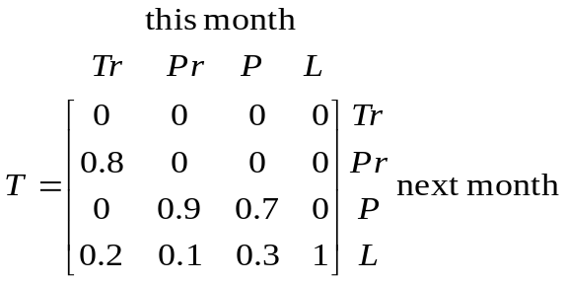

- i. Complete the transition diagram below using matrix T. Indicate the appropriate percentages on the diagram. 2 marks

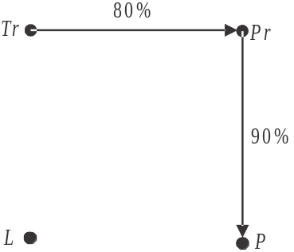

- How many trainees go on to become probationary staff members after one month into 2013? 1 mark

The initial state matrix, 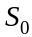, for the number of staff at this fast food outlet at the start of 2013 is given by
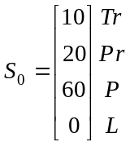

Let 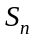 represent the state matrix which gives the number of staff at the fast food outlet at the end of the nth month in 2013.

- If no new staff are employed, then 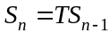.

In this case,

- find the total number of staff working at the outlet at the end of the first month. 1 mark

- find 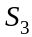. 1 mark

- find the months in 2013 when the owner had trainee staff and/or probationary staff. 1 mark

- find the month in 2013 during which the number of permanent staff first dropped below five. 1 mark

Assume that the owner of the fast food outlet can find more trainee, probationary and permanent staff. (These latter two categories he can source from other outlets in the same fast food chain.) He wishes to maintain each month the same number of staff as there are at the start of 2013.

- How many trainee, probationary and permanent staff does the owner have to employ at the end of each month to achieve this? 2 marks

Question 3 (3 marks)

The owner decides he wants to employ only new trainee staff. He also wants only new trainee staff who are siblings of his permanent staff. He believes that each month, 5% of his permanent staff would have a sibling who would be suitable to start as a trainee staff member.
His staffing model would therefore be defined by the rule 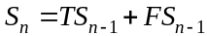 and the matrix , giving the number of staff at the end of the first month in January 2013 would therefore be defined as

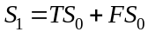 where

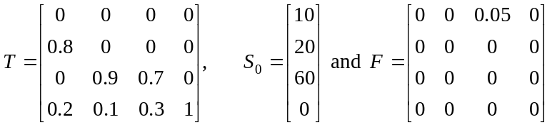

where the matrices T and 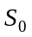 are the same matrices as used in Question 2.

- How many new trainee staff would be added in January 2013 according to this model? 1 mark

- How many probationary staff members will there be at the end of the second month in 2013 according to this model? Express your answer to the nearest whole number. 2 marks

Further Mathematics Formulas

Core: Data analysis

standardised score: 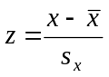
least squares line: 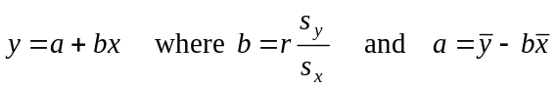
residual value: residual value = actual value – predicted value

seasonal index: seasonal index 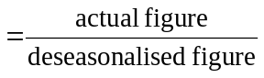

Module 1: Number patterns

arithmetic series: 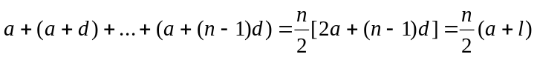
geometric series: 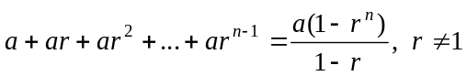
infinite geometric series: 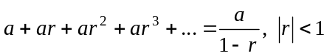

Module 2: Geometry and trigonometry

area of a triangle: 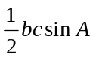
Heron's formula: 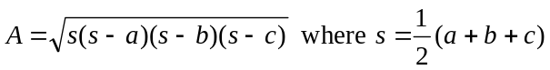
circumference of a circle: 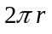

area of a circle: 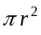

volume of a sphere: 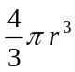
surface area of a sphere: 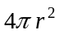

volume of a cone: 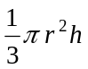
volume of a cylinder: 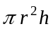

volume of a prism: 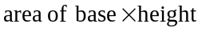
volume of a pyramid: 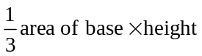

Mathematics Formula Sheets reproduced by permission; © VCAA 2013. The VCAA does not endorse or make any warranties regarding this study resource. Current and past VCAA VCE® exams and related content can be accessed directly at www.vcaa.vic.edu.au
Pythagoras’ theorem 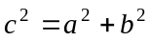

sine rule: 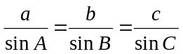
cosine rule: 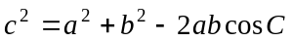

Module 3: Graphs and relations

Straight line graphs
gradient (slope): 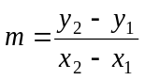
equation: 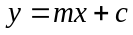

Module 4: Business-related mathematics

simple interest: 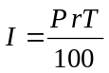
compound interest: 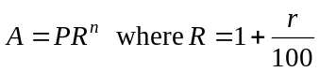
hire purchase: 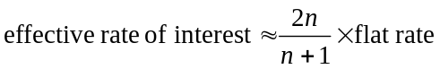

Module 5: Networks and decision mathematics

Euler’s formula: 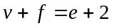

Module 6: Matrices

determinant of a 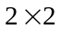 matrix 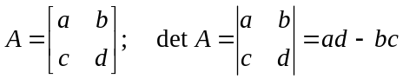
inverse of a matrix 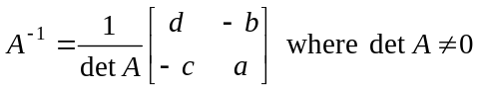

END OF FORMULA SHEET

